Activity 3: Build a spine
Now that we know why it is so important that we have so many vertebrae, let’s make some!
Learning objective: Understand why we have so many vertebrae by looking at two vertebrae and a disc and five vertebrae and four discs, why we have bone, discs, and the spinal cord, and how different back problems happen.
Materials: 7 Sourdough pretzels, 5 jumbo marshmallows, 2 pipe cleaners
Now we will be making two models of the spine, one with two vertebrae and one disc, one with five vertebrae and four discs.
If we have five vertebrae, which section of the spine are we looking at? ______________________
Part 1: Building one functional spine unit
But wait! What is a “functional spine unit”?
A functional spine unit has all the different materials that you can find in the spine. You can move it in all the ways you can move the whole spine. What do you think make up a functional spine unit?
- _______ Vertebra(e)
- _______ Disc(s)
- Part of the spinal cord

If you said 2 vertebrae and 1 disc, you’re exactly right!
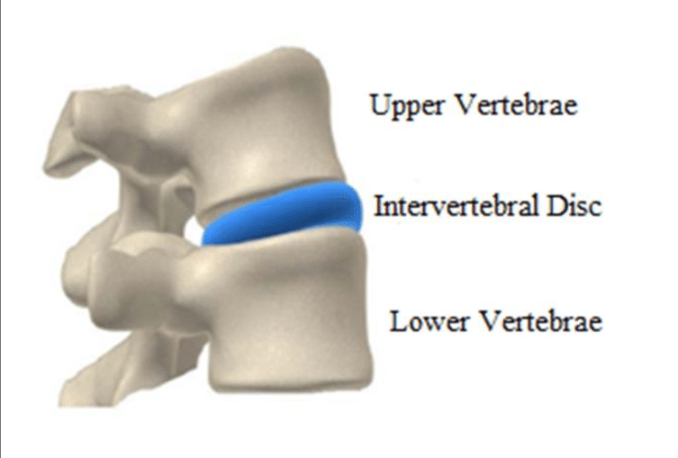
https://www.researchgate.net/profile/Saul-Iniguez-Macedo/publication/322609063/figure/fig1/AS:585567020539904@1516621465396/Functional-Spinal-Unit-FSU.png
Let’s make our functional spine unit model!
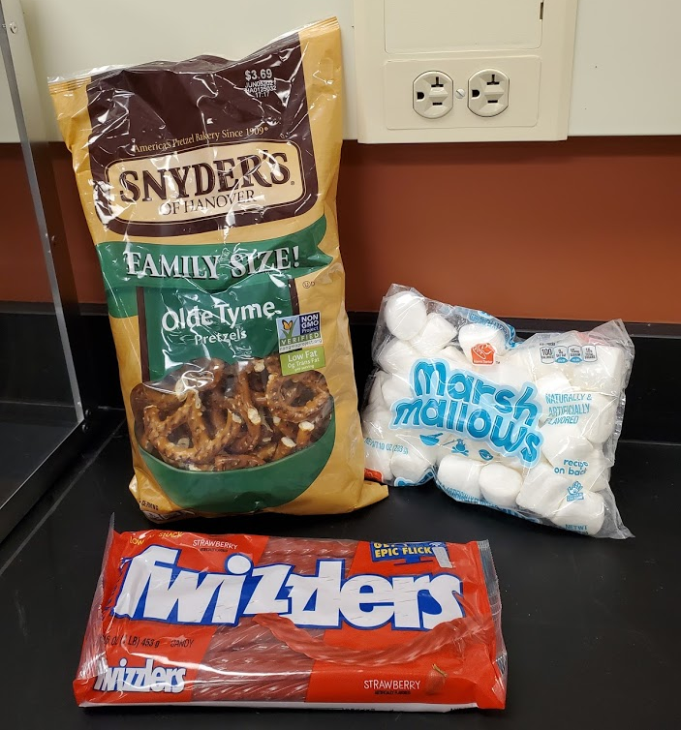
- Take out two pretzels, one marshmallow, and one twizzler
- Break off one of the “ears” of each pretzel
- Place the marshmallow on one of the pretzels
- Place the other pretzel on top of the marshmallow, being careful to place the pretzel the same way as the other one
- Place your twizzler through the other hole.
- Break the twizzler to length
Now that we have our functional spine unit, let’s put it through some tests.
- Push down on the top pretzel
  - What happened to the bones (pretzels)?______________________________________
  - What happened to the disc (marshmallow)? ___________________________________
  - What happened to the spinal cord (pipe cleaner)? ______________________________
  - What stopped you from pushing more? ______________________________________
- Pull up on the top pretzel
  - What happened to the bones (pretzels)?______________________________________
  - What happened to the disc (marshmallow)? ___________________________________
  - What happened to the spinal cord (pipe cleaner)? ______________________________
  - What stopped you from pulling more? ________________________________________
- Push the side of the top pretzel
  - What happened to the bones (pretzels)?______________________________________
  - What happened to the disc (marshmallow)? ___________________________________
  - What happened to the spinal cord (pipe cleaner)? ______________________________
  - What stopped you from pushing more? ______________________________________
- Hold the bottom pretzel and twist the top one like you are trying to open a jar.
  - What happened to the bones (pretzels)?______________________________________
  - What happened to the disc (marshmallow)? ___________________________________
  - What happened to the spinal cord (pipe cleaner)? ______________________________
  - What stopped you from twisting more? _______________________________________
Was there a lot of movement in the functional spine unit? (Circle one) Yes No
What could we do to get more movement? _________________________________________________

Great job! Now let’s build another model. This one will have 5 vertebrae just like the ______________ spine! How many discs will we need? _______
We will be building this one just like the one above. Use the same instructions this time, but build it higher!
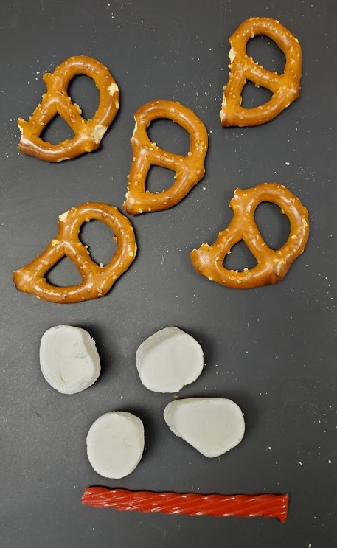
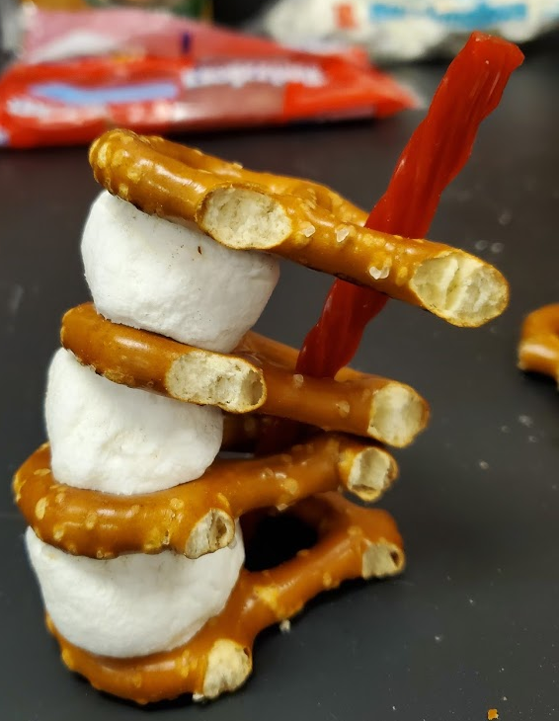
Now that we have our lumbar spine, let’s put it through some tests.
- Push down on the top pretzel
  - What happened to the bones (pretzels)?______________________________________
  - What happened to the disc (marshmallow)? ___________________________________
  - What happened to the spinal cord (pipe cleaner)? ______________________________
  - What stopped you from pushing more? ______________________________________
- Pull up on the top pretzel
  - What happened to the bones (pretzels)?______________________________________
  - What happened to the disc (marshmallow)? ___________________________________
  - What happened to the spinal cord (pipe cleaner)? ______________________________
  - What stopped you from pulling more? ________________________________________
- Push the side of the top pretzel
  - What happened to the bones (pretzels)?______________________________________
  - What happened to the disc (marshmallow)? ___________________________________
  - What happened to the spinal cord (pipe cleaner)? ______________________________
  - What stopped you from pushing more? ______________________________________
- Hold the bottom pretzel and twist the top one like you are trying to open a jar.
  - What happened to the bones (pretzels)?______________________________________
  - What happened to the disc (marshmallow)? ___________________________________
  - What happened to the spinal cord (pipe cleaner)? ______________________________
  - What stopped you from twisting more? _______________________________________
Was there more movement in the functional spine unit or lumbar spine? (Circle one)
Functional Lumbar
Why do we have hard bones instead of everything being like the marshmallow? _____________________________________________________________________________________
What do discs do? _____________________________________________________________________
Is the spinal cord (pipe cleaner) still okay after those tests? Remember, our spinal cord is what makes it so we can move all the parts of our bodies.
_____________________________________________________________________________________
Do you think it would be easy to hurt a disc or spinal cord? Yes No
What kind of movement would hurt the disc? _______________________________________________
What kind of movement would hurt the spinal cord? _________________________________________
Test out what could hurt these on your model.
What were your results? ________________________________________________________________
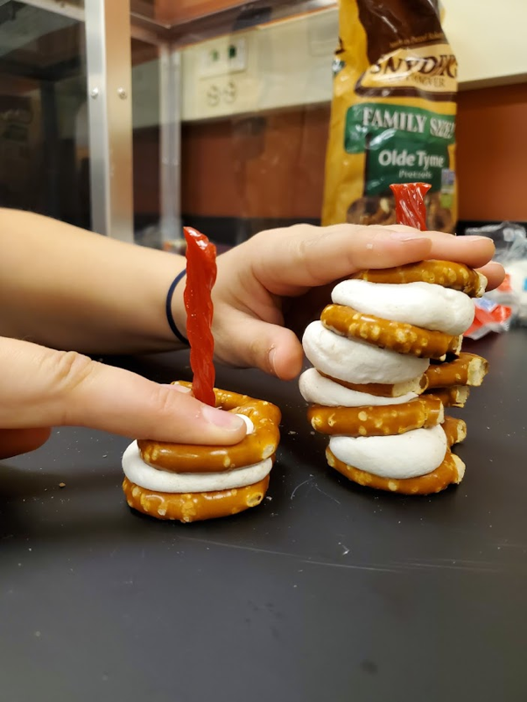
Just like in activity 2, we saw that being able to use many functional spine units makes it easier for us to move. You tested your theories on what could hurt your discs and spinal cord. Now lets test some other ideas, which you might have had yourself.
- Drop your lumbar spine from a few inches above your workspace, and look at the discs.
  - Which disc got smallest? _____________________________________________
  - Which one stayed closest to normal size? _______________________________
  - For the one that got smallest, did the marshmallow go to the sides? __________
This test looks at what happens to our spine when we jump and land. Some of the most common injuries are in the bottom of the spine because all the weight of the upper vertebrae, and your arms and head, are above them, so there’s a lot of weight on them.
- Hold the top pretzel and push the third one from the back (where the pipe cleaner is) forward.
  - What happened to the vertebra above and below the third one? __________________
  - What happened to the discs above and below that vertebra? _____________________
  - What happened to the pipe cleaner? _________________________________________
This test shows what can happen sometimes when you carry something too heavy and your back cannot handle it. It can make the spinal cord get smaller, which hurts a lot.
- Now let’s use our functional spine unit model. Push on the top pretzel as hard as you can
  - What happened to the marshmallow? ________________________________________
Sometimes when there’s too much weight on the spine, the disc can bulge out, which also hurts a lot.

